There are many approaches to software update. Broadly, I characterize them as:
- Local update, often performed by a technician who carries the update on a portable medium such as a USB flash drive or an SD card, and has to access each system individually
- Remote update, where the update is initiated by the user or a technician locally, but it is downloaded from a remote server
- Over-the-air (OTA) update, where the update is pushed and managed entirely remotely, without any need for local input

Most update solutions leave the bootloader alone. This is not a big problem, because the bootloader only runs for a short time at power-on and is not normally a great source of run-time bugs.

The kernel and DTB may be stored in the root filesystem, so long as the bootloader has the ability to read that filesystem format, or it may be in a dedicated partition. In either case, it is possible to have redundant copies.

The root filesystem contains the essential system libraries, utilities, and scripts needed to make the system work. It is very desirable to be able to replace and upgrade all of these. The mechanism depends on the implementation. Common formats for embedded root file systems are:
- Ramdisk, loaded from raw flash memory or a disk image at boot. To update it, you just need to overwrite the ramdisk image and reboot.
- Read-only compressed filesystems, such as squashfs, stored in a flash partition. Since these types of filesystem do not implement a write function, the only way to update them is to write a complete filesystem image to the partition.
- Normal filesystem types. For raw flash memory, JFFS2 and UBIFS formats are common, and for managed flash memory, such as eMMC and SD cards, the format is likely to be ext4 or F2FS. Since these are writable at runtime, it is possible to update them file by file.

The system applications are the main payload of the device; they implement its primary function. As such, they are likely to be updated frequently to fix bugs and to add features. They may be bundled with the root filesystem, but it is also common for them to be placed in a separate filesystem to make updating easier and to maintain separation between the system files, which are usually open source, and the application files, which are often proprietary.

Device specific data is the combination of files that are modified at runtime, and includes configuration settings, logs, user-supplied data, and the like. It is not often that they need to be updated, but they do need to be preserved during an update. Such data needs to be stored in a partition of its own.

An update may include new versions of the kernel, root filesystem, and system applications. The device will have other partitions that should not be disturbed by an update, as is the case with the device runtime data.

The software update mechanism must be:
- Robust, so that an update does not render the device unusable
- Fail-safe, so that there is a fall-back mode if all else fails
- Secure, to prevent the device from being hijacked by people installing unauthorized updates
The update as a whole must be atomic: there should be no stage at which part of the system is updated but not other parts. There must be a single, uninterruptible change to the system that switches to the new version of software.

To achieve atomicity, the update must be installed alongside the running system, and then a switch thrown to move from the old to the new. Two different approaches to achieving atomicity.

The first is to have two copies of the root filesystem and other major components. One is live, while the other can receive updates. When the update is complete, the switch is thrown so that on reboot, the bootloader selects the updated copy. This is known as symmetric image update, or A/B image update.
A variant of this theme is to use a special recovery mode operating system that is responsible for updating the main operating system. The guarantee of atomicity is shared between the bootloader and the recovery operating system. This is known as asymmetric image update. It is the approach taken in Android prior to the Nougat 7.x version.

The second approach is to have two or more copies of the root filesystem in different subdirectories of the system partition, and then use chroot(8) at boot time to select one of them. Once Linux is running, the update client can install updates into the other root filesystem, and then when everything is complete and checked, it can throw the switch and reboot. This is known as atomic file update, and is exemplified by OSTree.

Making updates fail-safe
The next problem to consider is that of recovering from an update that was installed correctly, but which contains code that stops the system from booting. Ideally, we want the system to detect this case and to revert to a previous working image.
There are several failure modes that can lead to a non-operational system. The first is a kernel panic, caused for example by a bug in a kernel device driver, or being unable to run the init program. A sensible place to start is by configuring the kernel to reboot a number of seconds after a panic. You can do this either when you build the kernel by setting CONFIG_PANIC_TIMEOUT or by setting the kernel command line to panic. For example, to reboot 5 seconds after a panic, you would add panic=5 to the kernel command line.
Oops is generated when the kernel encounters a fatal error. In some cases, it will be able to recover from the error, in other cases not, but in all cases, something has gone wrong and the system is not working as it should. To enable panic on Oops in the kernel configuration, set CONFIG_PANIC_ON_OOPS=y or, on the kernel command line, oops=panic.

A second failure mode occurs when the kernel launches init successfully but for some reason the main application fails to run. For this, you need a watchdog. A watchdog is a hardware or software timer that restarts the system if the timer is not reset before it expires. If you are using systemd, you can use the inbuilt watchdog function.
Both failures result in boot loops: either a kernel panic or a watchdog timeout causes the system to reboot. If the problem is persistent, the system will reboot continually. To break out of the boot loop, we need some code in the bootloader to detect the case and to revert to the previous, known good, version. A typical approach is to use a boot count that is incremented by the bootloader on each boot, and which is reset to zero in user space once the system is up and running. If the system enters a boot loop, the counter is not reset and so continues to increase. Then, the bootloader is configured to take remedial action if the counter exceeds a threshold.
In U-Boot, this is handled by three variables:
- bootcount: This variable is incremented each time the processor boots
- bootlimit: If the bootcount exceeds the bootlimit, U-Boot runs the commands in altbootcmd instead of bootcmd
- altbootcmd: This contains the alternative boot commands, for example to roll back to a previous version of software or to start the recovery-mode operating system
For this to work, there must be a way for a user space program to reset the boot count. We can do that using U-Boot utilities that allow the U-Boot environment to be accessed at runtime:
- fw_printenv: Prints the value of a U-Boot variable
- fw_setenv: Sets the value of a U-Boot variable
These two commands need to know where the U-Boot environment block is stored, for which there is a configuration file in /etc/fw_env.config. For example, if the U-Boot environment is stored at offset 0x800000 from the start of the eMMC memory, with a backup copy at 0x1000000, then the configuration would look like this:
# cat /etc/fw_env.config
/dev/mmcblk0 0x800000 0x40000
/dev/mmcblk0 0x1000000 0x40000
Incrementing the boot count on each boot and then resetting it when the application begins to run leads to unnecessary writes to the environment block, wearing out the flash memory and slowing down system initialization. To prevent having to do this on all reboots, U-Boot has a further variable named upgrade_available. If upgrade_available is 0, then bootcount is not incremented. upgrade_available is set to 1 after an update has been installed so that the boot count protection is in use only when it is needed.

Making updates secure
-provide a reliable, automated or semi-automated method to install security patches and new features.

The biggest vulnerability is that of a fake remote update. To prevent this, we need to authenticate the update server before starting the download. We also need a secure transfer channel, such as HTTPS, to guard against tampering with the download stream.

There is also the question of the authenticity of updates supplied locally. One way to detect a bogus update is to use a secure boot protocol in the bootloader. If the kernel image is signed at the factory with a digital key, the bootloader can check the key before it loads the kernel and refuse to load it if the keys do not match. So long as the keys are kept private by the manufacturer, it will not be possible to load a kernel that is not authorized. U-Boot implements such a mechanism, which is described in the U-Boot source code in doc/uImage.FIT/verified-boot.txt.

Types of Update Mechanism

three approaches to applying software updates: symmetric, or A/B, image update; asymmetric image update, also known as recovery mode update; and finally, atomic file update.

Symmetric image update
In this scheme, there are two copies of the operating system, each comprising the Linux kernel, root filesystem, and system applications. They are labelled as A and B
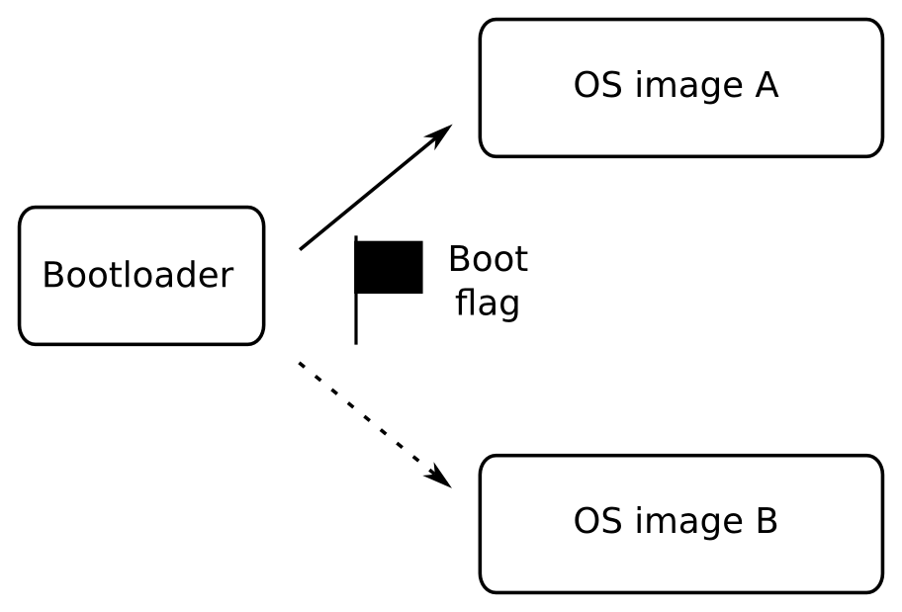

The bootloader has a flag that indicates which it should load. Initially, the flag is set to A, so the bootloader, loads OS image A. To install an update, the updater application, which is part of the operating system, overwrites OS image B. When complete, it changes the Boot flag to B and reboots. Now the bootloader will load the new operating system. When a further update is installed, the updater overwrites image A and changes the Boot flag to A, and so you ping-pong between the two copies. If an update fails before the Boot flag is changed, the bootloader continues to load the good operating system.

